Auto Ticket Classification using Flow Designer
Part 2 of 7 — Update Set Navigation & Custom Table CreationPart 2 of 7 — Update Set Navigation & Custom Table Creation

Activity 3: Navigation Steps in Picture View
The following screenshots show the navigation path used to create and activate the Update Set.
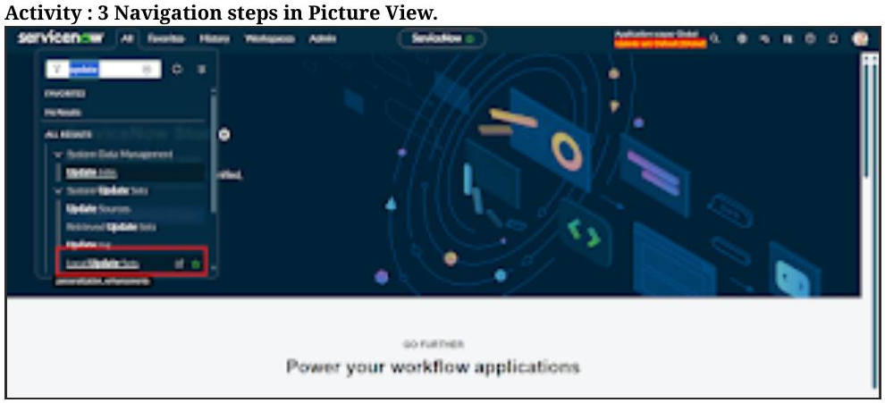
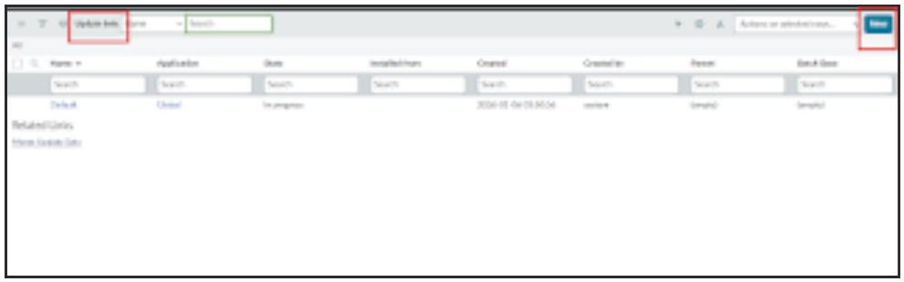
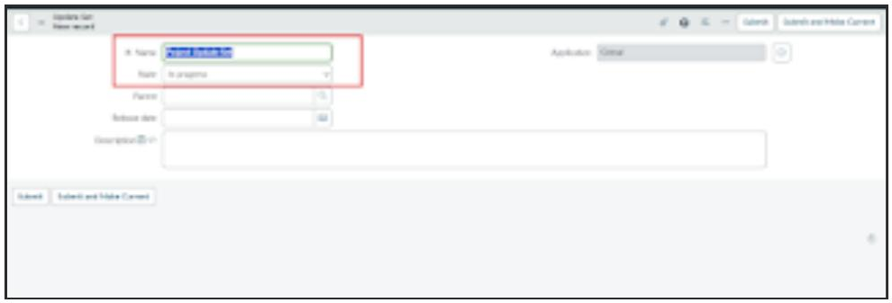
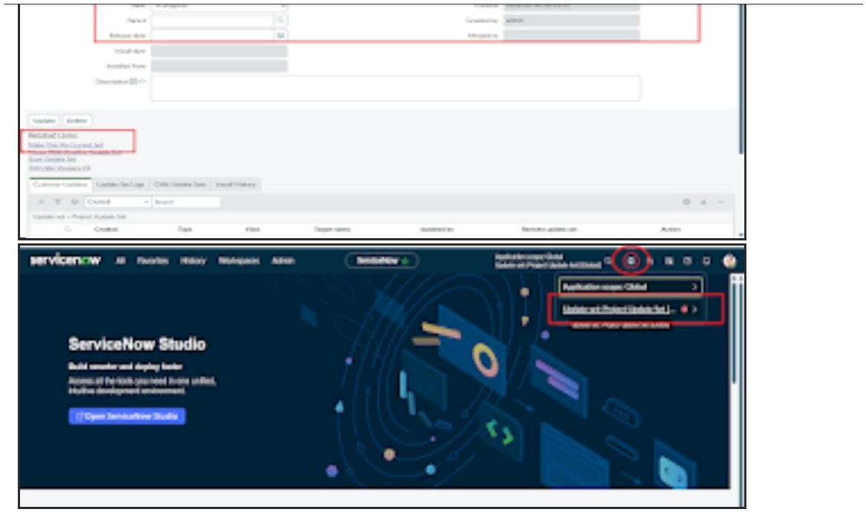

Phase 2: Backend Development & Configuration

Activity 1: Creation of Custom Table to Store Ticket Records
Steps to Create Custom Table:
- Open All menus → Search for Tables.
- Under System Definition → Click Tables.
- On the top right corner Click New button.
- Label: Incident WorkFlow.
- Uncheck the Create module.
- Now Save the Form.
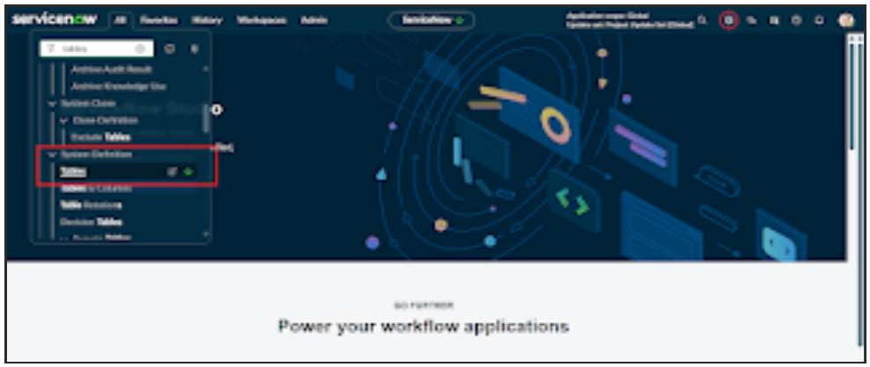
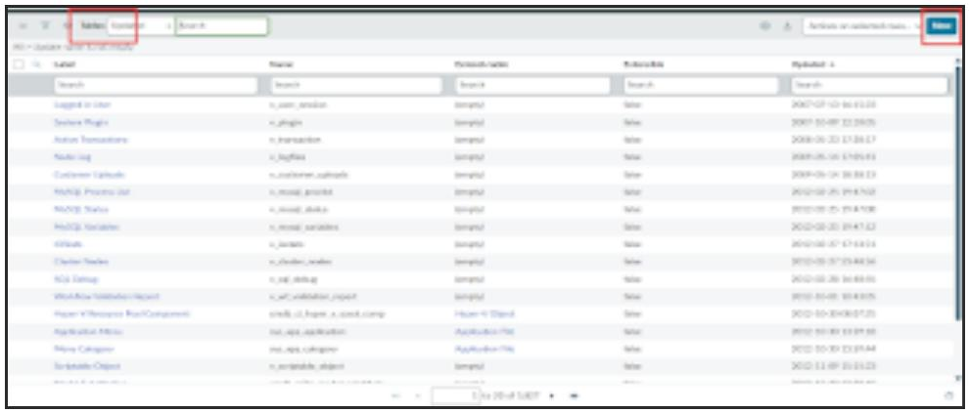
- Then Click the Controls section and Enable the checkbox true Auto Number.
- Now again save the Form.
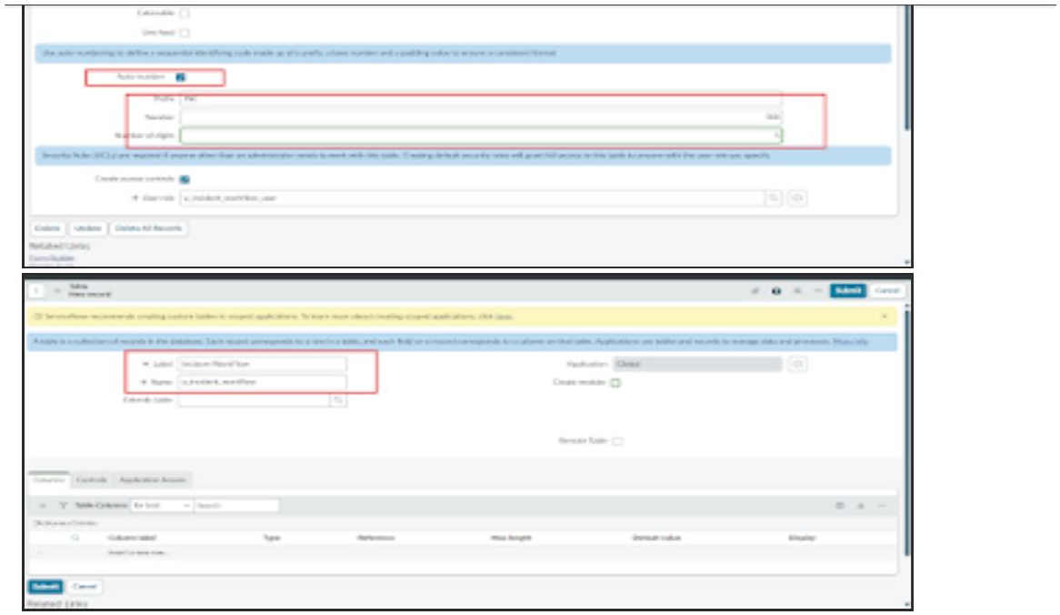
- Then Save the Form and Under Related Links Click Show Form.
- Now Open the Configure on clicking the Context Menu and then Open the Form Designer.
- Then Create Fields as Required.

